**Task No: 1**

#include <iostream>

using namespace std;

int main()

{

int n, addition = 0;

int i = 1;

cout << "Enter the numbers to add: ";

cin >> n;

while (i <= n)

{

addition = addition + i;

i+=1;

}

cout << "The sum of first " << n << " natural numbers is: " << addition << endl;

return 0;

}

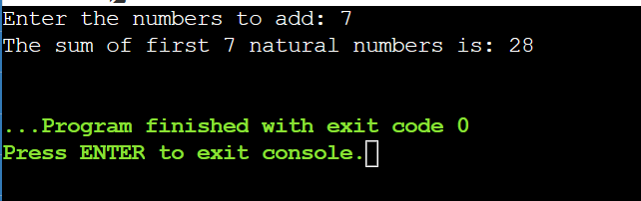

**Task No: 2**

#include <iostream>

using namespace std;

int main()

{

int integer;

cout << "Enter the number: ";

cin >> integer;

cout << "The table of " << integer << " is:" << endl;

for (double z = 1; z <= 100; z++)

{

cout << integer << " x " << z << " = " << integer * z<< endl;

}

return 0;

}

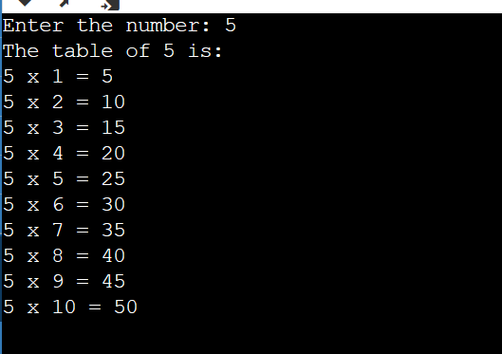

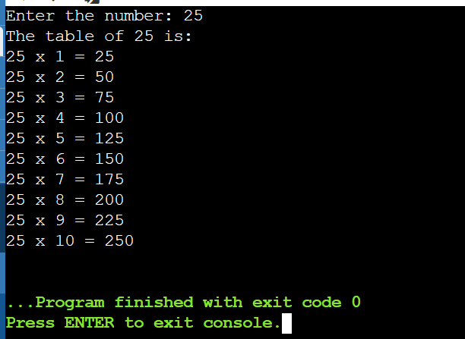

**Task No: 3**

#include <iostream>

using namespace std;

int main()

{

int p;

cout << "Enter a number: ";

cin >> p;

int factorial = 1;

for (int i = 1; i <= p; i++)

{

factorial = factorial * i;

}

cout << "Factorial of " << p << " is: " << factorial<< endl;

return 0;

}

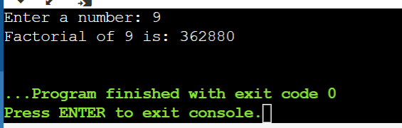

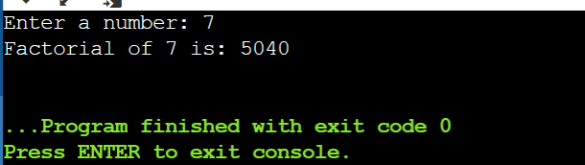

**Task No: 4**

#include <iostream>

using namespace std;

int main(){

int bic, jim = 1, i = 0;

int n;

cout<<"Enter a number:"<<endl; cin>>n;

cout<<"The fibonacci sequence for "<<n<<" number is:"<<endl;

for (int i = 1; i<n; i++)

if (i<=1) {

bic= i;

} else {

bic = i + jim;

i = jim;

jim= bic;

cout<<bic<<endl;

}

return 0;

}

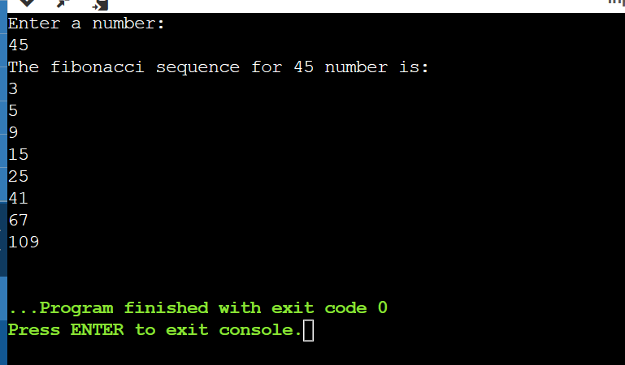

**THE END**